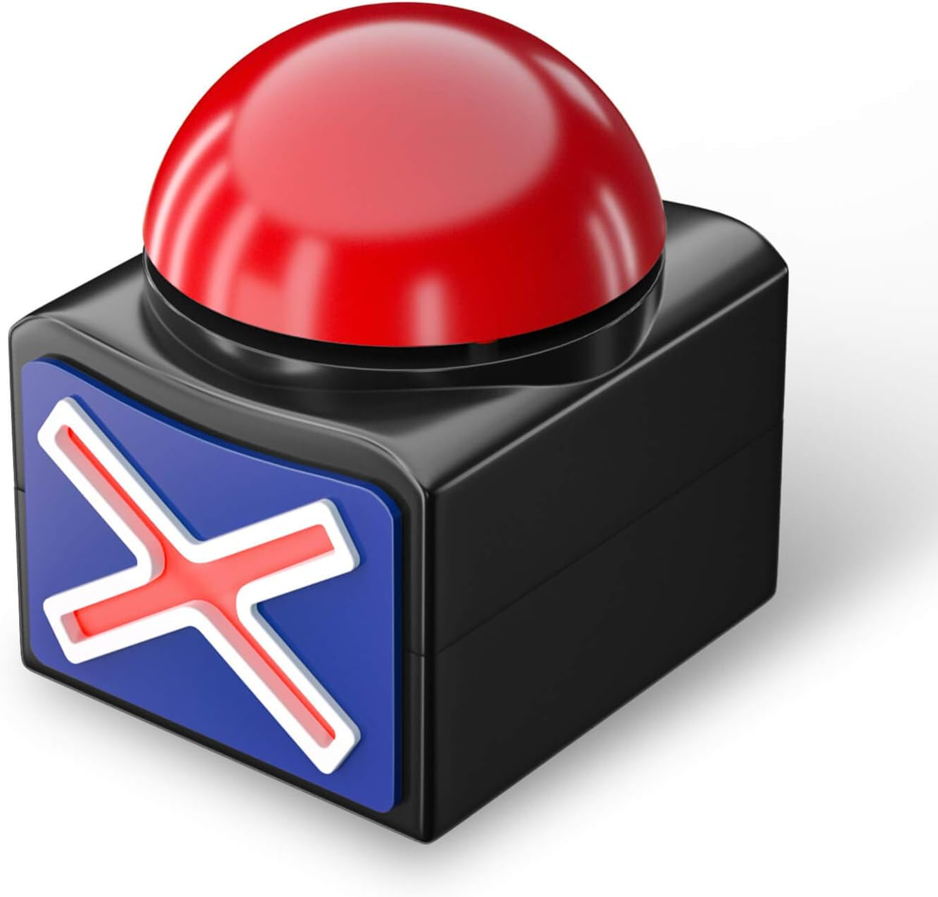**CGS Buzzer System**

**Usage Instructions**

**Table of Contents**

|  |  |
| --- | --- |
| **1: Buzzer Setup** | **2** |
| 1.1: Flashing the Micro:bits |  |
| 1.2: Inserting into the Buzzer |  |
| 1.3: Buzzer IDs |  |
| 1.4: Buzzer States |  |
| **2: Controller App** | **??** |
| 2.1: The Interface |  |
| 2.2: Pre-Game Setup |  |
| 2.2.1: Team Setup |  |
| 2.2.2: Question Sets |  |
| 2.3: Big Picture Guide |  |
| 2.4: Hosting a Game |  |
| **Set Creation** | **??** |
|  |  |

**2**

**Controller App**

|  |  |
| --- | --- |
| 2.1: The Interface |  |
| 2.1.1: Hosting Tab |  |
| 2.1.2: Big Picture Configuration Tab |  |
| 2.1.3: Team Setup Tab |  |
| 2.1.4: Scoreboard Tab |  |
| 2.1.5: Soundboard Tab |  |
| 2.1.6: Buzzer Function Tab |  |
| 2.2: Pre-Game Setup |  |
| 2.2.1: Team Setup |  |
| 2.2.2: Question Sets |  |
| 2.3: Using the Big Picture Display |  |
| 2.3.1: Display Pages |  |
| 2.4: Hosting a Game |  |

IMPORTANT: The Controller App will not load unless the controller Micro:bit is connected to your device via USB. Please ensure it is connected before you try to follow these instructions!

**2.1: The Interface**

The Controller App uses a tabbed interface, so most of the functions you need to setup and run a game will be found on different pages.

Below is a brief overview of all the tabs (and their functions) in the app.

Hosting Tab:

Tab switching buttons

Question Set Frame – displays the name of the current question set, and the current round. Also contains the button to load a question set.

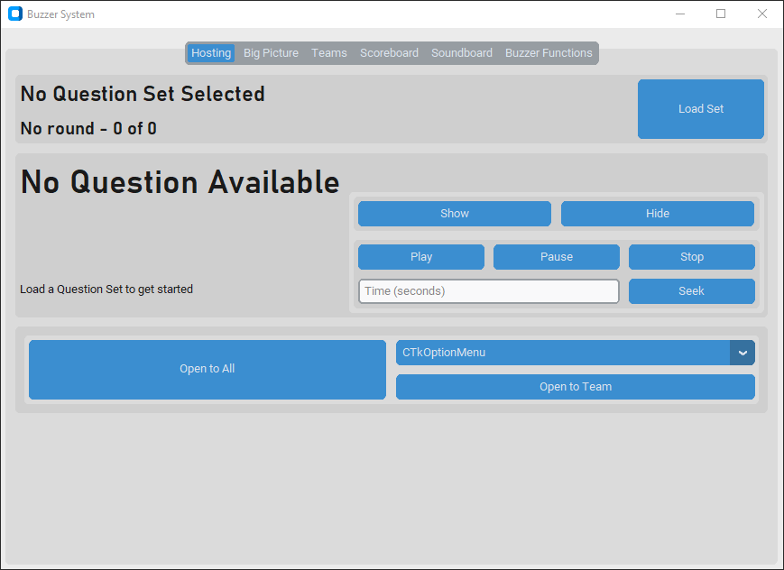

Buzzer Control – contains options to open, close or lock buzzers. The available buttons will change depending on the state of the buzzers (full guide in 2.4)

Displays the current question, answer, and notes.

Question Aid Control – contains the controls for media (video, audio, or images) embed in questions.

The Hosting tab is probably where you will spend most of your time when hosting the game.

It gives you access to all the information and controls you need regarding questions and buzzer control. The only things related to hosting that cannot be found in this tab are the live scoreboard – for that you would need to switch to the “Scoreboard” tab; and sound effect panel – which is in the “Soundboard” tab.

Big Picture Configuration Tab:

Set the title to display on the Big Picture (the button must be pressed for changes to take effect).

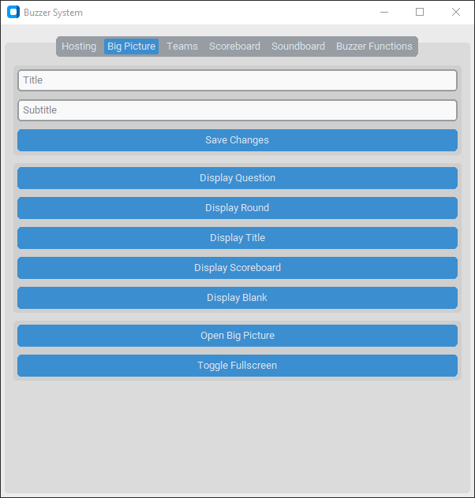

These buttons can be used to change the page that the Big Picture is displaying.

These buttons can be used to open and full screen the Big Picture display.

The Big Picture Display is what the audience will see of your gameshow. It can be used to display lots of different information about the current question, round, set or scores (more about that in 2.3).

This tab allows you to switch between all the different views of the Big Picture (Question, Round, Title, Scoreboard, or Blank); open and full screen display; and set a title for your event (which will be displayed in the Title page).

Team Setup Tab:

These buttons allow you to save and reload team configurations.

Send the displayed team configuration to the controller Micro:bit, which starts the system. No changes will be saved unless this button is pressed.

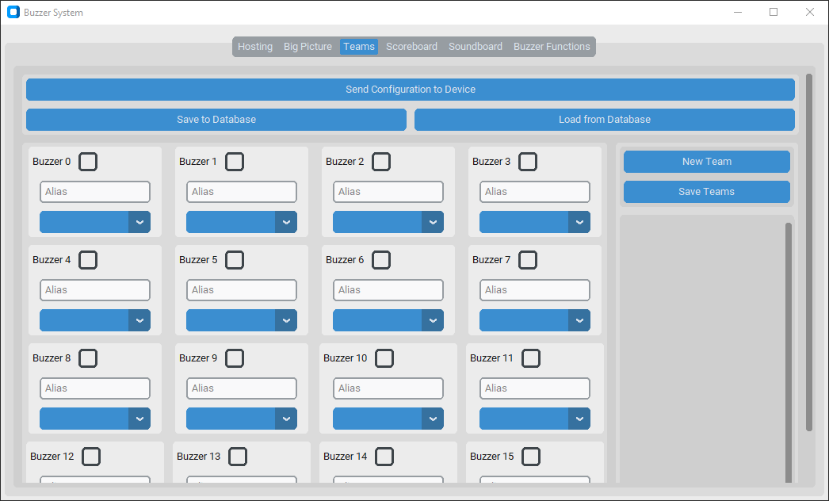

Team Settings – add new teams and adjust their names and colour palettes.

Buzzer Settings – update the alias, team and ‘is enabled?’ value of each buzzer.

This is the tab that you will probably end up using first. This is how you setup the buzzers and configure teams, aliases, and colour palettes.

For a full guide on team setup, skip to 2.2.1.

Scoreboard Tab:

These buttons allow manual control over the score of each team. You can manually apply penalties or bonuses to each team individually.

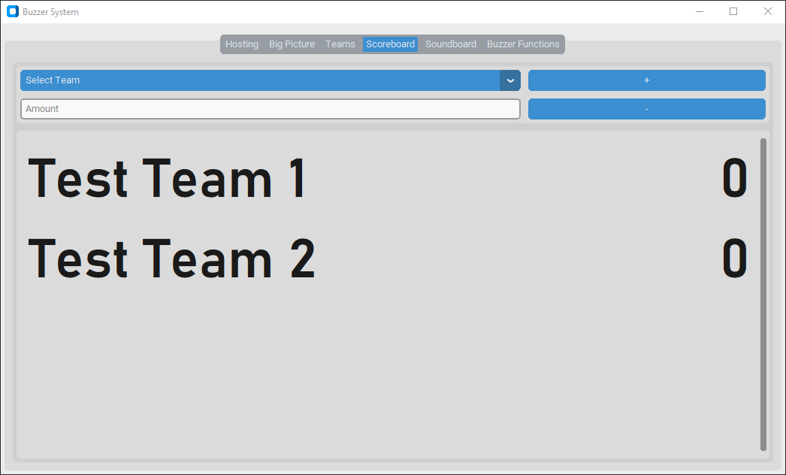

This is where you can see the scores. Each team has its name on the left and their score on the right.

This tab is simple, and just allows the host to view and edit the scores of each team individually.

Soundboard Tab:

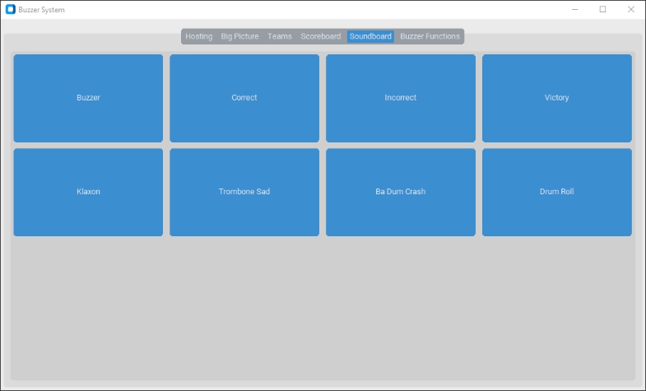

This tab allows the host to play sound effects to the audience whenever they please throughout the game.

There are some built into the running (like Buzzer, Correct, and Incorrect).

Buzzer Functions Tab:

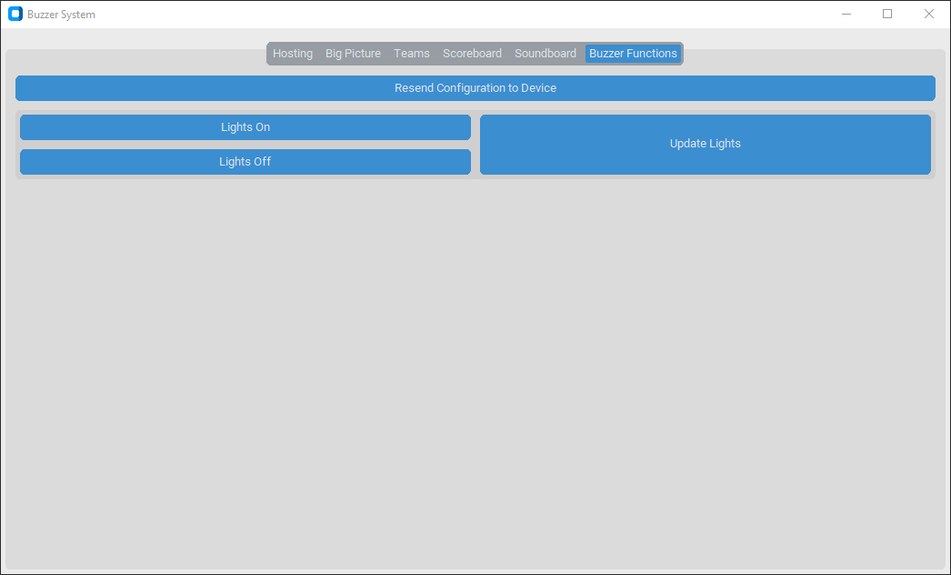

This tab only contains buttons for a few functions, and they probably wouldn’t be used very often (but may be necessary).

**Resend Configuration to Device** – this instructs the controller to resend the configuration it currently has stored to each buzzer. This is most likely to be used if you add a new buzzer midway through the game (as the “Send Configuration to Device” in the Team Setup tab will reset the scores to 0, but this will not).

**Lights On / Off** – tell the buzzers to turn on or off their internal LEDs.

**Update Lights** – if a buzzer were to freeze and stop responding, this can be used to force it to update its state. If this fails to fix the option, you should use “Resend Configuration to Device” above.

That’s the interface in a nutshell. We’ll take a closer look at most of the tabs as we go through the process of setting up and hosting a game. Firstly, let’s look at the things you must do before your audience arrives.

**2.2: Pre-Game Setup**

Before your audience arrives, it is important to setup your Buzzer System, so that your hosting experience goes off without a hitch.

Although you can do the following the other way round, it is recommended that you setup the buzzers (with aliases and teams) and then load your question set.

Team Setup:

IMPORTANT: This tutorial assumes that you have already completed the Buzzer Setup tutorial in Section 1.

There are two options for setting up teams: loading an existing configuration from the local database; or manually creating and defining each team.

**Loading from Database**

Only do this if you know you have previously saved a configuration that you can load.

If you use this method, you can always edit the configuration, before you send it to the device. Follow the other instructions below once you’ve loaded it.

1. Switch to the Team Setup tab.
2. Click the “Load from Database” button.

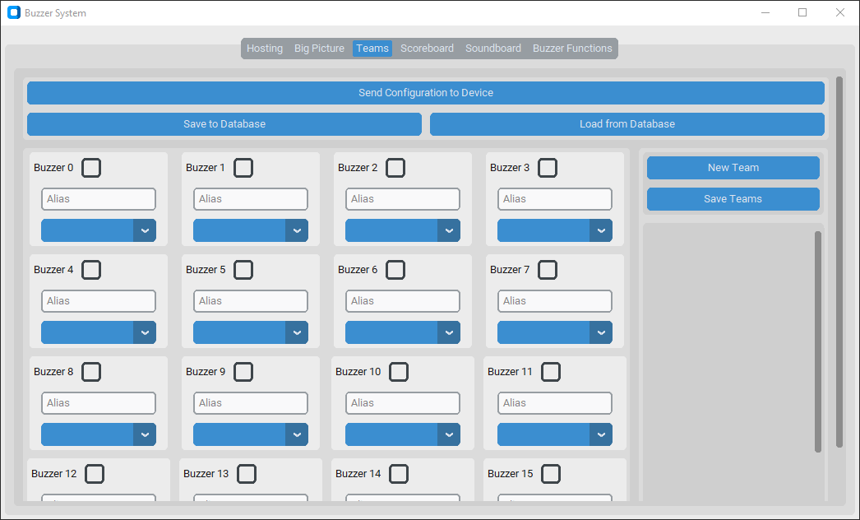

1. In the prompt that pops up, select the name of the configuration that you want to load from the dropdown, and click submit.
2. Set the colour palettes for each team (by following the tutorial below).
3. Make any changes that you want to (like aliases or team names).
4. Press “Send Configuration to Device” to push the new configuration to the controller Micro:bit and each of the buzzers.

**Manually Creating Configuration**

1. Create the teams.
   1. Press “New Team”. A new ‘box’ containing the team data will appear at the bottom of the list.
   2. Enter the name of the team in the text entry box.
   3. Set / select the colour palette for the team.
      1. Set the colour for each of the states (by clicking on the button labelled with that state and select a colour from the prompt that comes up).
      2. OR… click “Load Colour Palette” and select the name of the colour palette from the prompt that opens. *There are pre-created colour palettes for each of the 5 Houses.*
   4. Repeat for each of the teams you need.
   5. Press “Save Teams” to update the team list on each of the buzzers.
2. Set configuration for each buzzer.
   1. By referring to your “Buzzer Plan Sheet”, check if the buzzer needs to be enabled and check the checkbox in the top-right corner as needed.
   2. Set the alias (the name of the person using the buzzer) using the text entry box.
   3. Set the team by selecting the desired one from the dropdown menu.
   4. Repeat this for each buzzer (0-16).
3. Click “Send Configuration to Device” once you are happy with the setup.

Now your buzzers should be setup and displaying the correct “Inactive” colour for the team that they have been assigned to.

**Saving Colour Palettes & Team Configurations**

If you create a colour palette that you want to save, click the “Save Colour Palette” button in the team (whose colour palette you want to save). Enter the name you want to give it in the popup, and press submit.

If you create a colour palette that you want to save, click the “Save to Database” button. Enter the name you want to give it in the popup, and press submit.

N.B.: for both colour palettes and team configurations, if you give them a name that is not unique, it will overwrite the current data.

Question Sets:

Your question set should be written before you begin your event setup (using the Set Creator app – tutorial in Section 3).

Loading a question set is as simple as switching to the Hosting tab and pressing the “Load Set” button. You should then just be able to select the name of the set in the dropdown of the prompt and it will load into the software.

The only thing left to do before your event begins is to setup the Big Picture Display. Learn about that next.

**2.3: Using the Big Picture Display**

The Big Picture Display is a way of displaying key information about the game to the audience.

It can display custom titles, the current round, question, and scoreboard with just a press of a button.

To get started, open the Big Picture Display by switching to the Big Picture Configuration tab and pressing “Open Big Picture”.

This should open a blank, black window.

You can use the “Toggle Fullscreen” button to full screen the display on your primary monitor (if you want the Big Picture on a secondary display – like a projector – you should change that to be your main display in your device’s display settings).

Display Pages:

There are 5 different pages that can be displayed on the Big Picture:

**Blank** – just a black screen. Useful if you want to hide the question until you have finished reading it.

**Title** – displays the title and subtitle that is set in the Big Picture Configuration tab.

**Round** – displays the name and number of the current round.

**Question** – displays the text of the question and any media associated with it (otherwise known as the question aid).

**2.4: Hosting a Game**

There are a lot of controls to understand when hosting a game with the buzzer system, but descriptions below should explain everything you need to know.

Buzzer Controls:

There are 5 different panes that show in the Buzzer Control area depending on what state the buzzers are in.

**Buzzers Closed**

This displays when the buzzer entry is closed with no one buzzing.

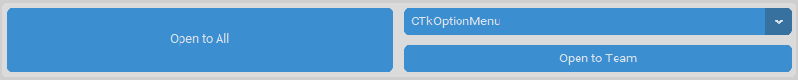

Open to All – put all unlocked buzzers into the “Waiting” state.

Open to Team – put all unlocked buzzers from the selected team into the “Waiting” state. All other buzzers become “Inactive”.

**Waiting for Buzz**

This displays when the buzzer entry is open.



Close Entry – puts all buzzers into the “Inactive” state.

Skip Question – moves to advance question without applying any penalty. Plays incorrect sound effect.

**Someone Buzzed**

This displays when a buzzer press has been received and accepted. The name and team of the person who buzzed will be shown in the top-left corner.

Reopen to All – puts all unlocked buzzers into the “Waiting” state.

Reopen – Lock Individual – locks the individual who buzzed in, and then put all unlocked buzzers into the “Waiting” state.

Reopen – Lock Team – locks the entire team of the individual who buzzed in, and then put all unlocked buzzers into the “Waiting” state.

Reset – unlock all buzzers, and then put them into an “Inactive” state.

Correct – apply a points bonus to the team that buzzed in, then move to advance to the next question.

Skip Question – make no changes to the scores, then move to advance to the next question.

Incorrect – apply a penalty to the team that buzzed in, then move to advance to the next question.

**Advance Question**

Displays when another button has been used to advance to the next question. This display acts as a confirmation that you’re ready to move on.



Next Question – actually advance to the next question.